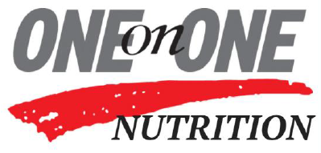
Homemade Pasta Sauce
Makes: 6 cups
Recommended serving size: ½ cup

Ingredients
1 teaspoon olive oil
1 small yellow onion, finely diced
3 cloves garlic, minced
1 (28 oz) can whole peeled tomatoes
1 bay leaf
3 tablespoons Italian seasonings

Directions:
- Heat oil over medium-high heat. Add the onions and sauté until softened and translucent, 5 to 7 minutes. Stir in the garlic and sauté until fragrant, about 30 seconds.
- Add the tomatoes and their juices to the pan with the onions. Crush the tomatoes in your hand as you add them, or smash them against the sides of the pan with your spatula. Alternatively, you can cut the tomatoes with kitchen shears while they're still in the pan.
- Add the bay leaf and seasonings to the pan with the sauce.
- Bring the sauce to a simmer and continue until the sauce has thickened, about 20 minutes.
- Remove the bay leaf. Serve the sauce immediately over pasta.

Nutrition information per serving: 40 calories, 7 grams carbohydrates, 1 gram protein, 0.5 grams fat, 2 grams fiber

